Power BI Report
Q1. Question Statement: Identify and visually represent the top 10 product categories by total sales.
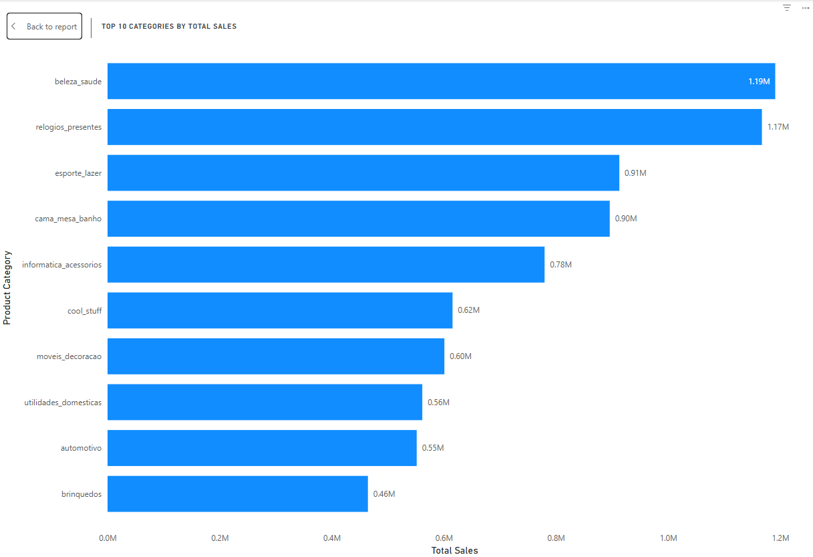
The sales distribution shows beauty and health (beleza_saude) as the leading category at ~1.19M, closely followed by relogios_presentes at ~1.17M, reflecting competitive dominance. Other significant contributors include esporte_lazer (0.91M) and cama_mesa_banho (0.90M), with informatica_acessorios generating ~0.78M. Lower tier but notable performers include cool_stuff (0.62M), moveis_decoracao (0.60M), utilidades_domesticas (0.56M), and automotivo (0.55M). Collectively, these categories highlight that consumer demand is strongest for lifestyle, personal care, and gifting items. The narrow margin between the top two categories suggests a highly competitive market, where even small promotional campaigns or discount strategies could shift leadership. Long-tail categories, though smaller, provide diversification opportunities when strategically bundled.
Q2. Question Statement: Identify and visually represent states with high and low sales.
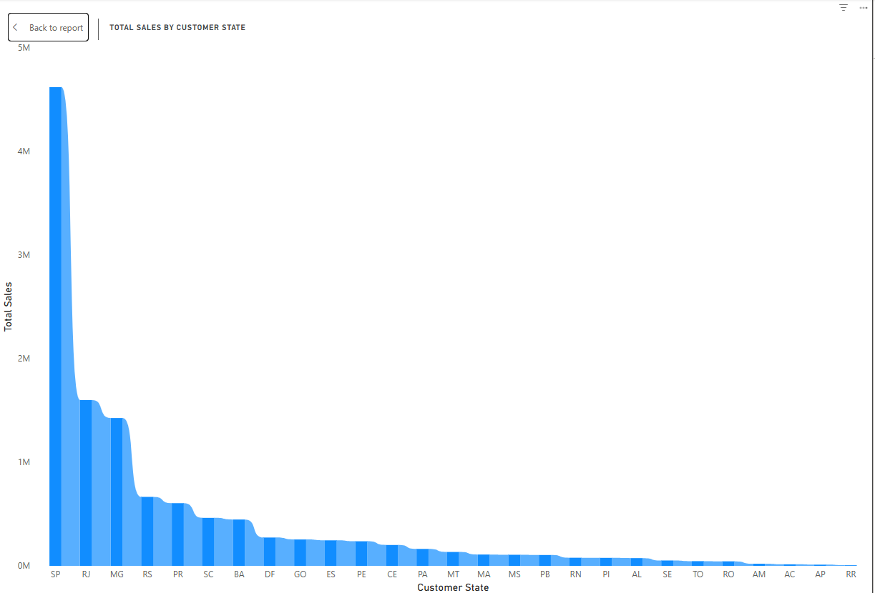
Geographic analysis reveals that São Paulo (SP) is the revenue powerhouse, generating ~4.6–4.7M, far exceeding other states. Rio de Janeiro (RJ) follows at ~1.5–1.7M, while southern states (RS, PR, SC) form the next significant cluster, contributing between 0.9–1.3M each. Beyond these regions, sales taper sharply, with states like BA, DF, GO, ES, PE, CE and others typically below 0.3M. The sharp drop-off demonstrates SP’s outsized influence, indicating a “hub-and-spoke” dynamic where one mega-market anchors overall performance. Regional campaigns in RJ and the southern cluster could drive incremental growth, while targeted payment methods like boleto may better serve customers in underpenetrated states. Mapping state-level revenue to delivery performance can also expose regional bottlenecks.
Q3. Question Statement: Analyze the most frequently used payment methods.
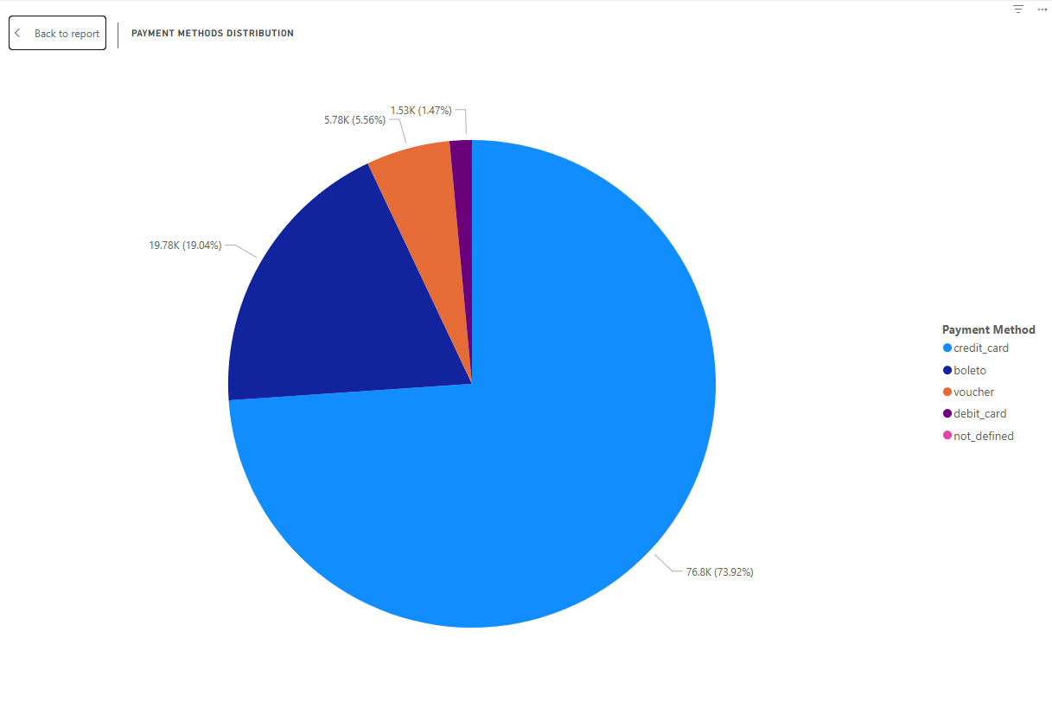
Payment data shows heavy reliance on credit cards, with ~76.8k transactions (73.9%), underscoring the central role of installments in driving consumer purchases. Boleto is the next major method, used in ~19.8k transactions (19.0%), highlighting customer segments preferring offline or delayed payments, often in specific regions. Vouchers, though smaller at ~5.8k (5.6%), may be important for promotions or bulk orders, while debit card and undefined methods are marginal. This breakdown emphasizes the need to maintain seamless card processing infrastructure while strategically promoting boleto in areas with lower card adoption. Enhancing boleto usability and leveraging voucher campaigns could broaden accessibility, but credit-card robustness remains critical for sustaining revenue growth.
Q4. Question Statement: Investigate and visualize any seasonal sales patterns (Quarterly).
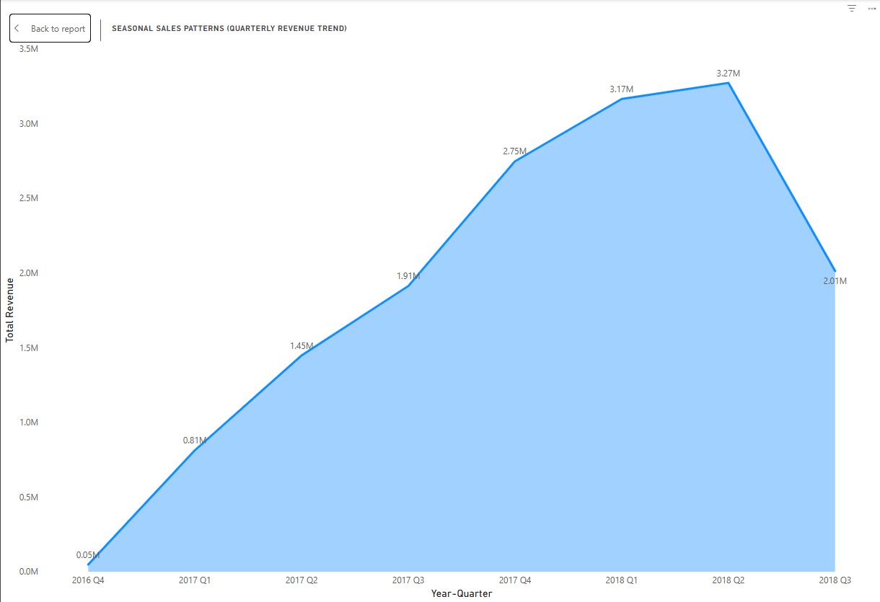
Quarterly revenue patterns highlight steady upward momentum from 2016 Q4 through 2018 Q2, reaching a peak of ~3.3M, before softening to ~2.0M in 2018 Q3. Revenue milestones include 0.8M, 1.4M, 1.9M, and 2.7M, showing consistent scaling with each quarter. The climb indicates expanding demand and effective order conversion, particularly through 2017 and early 2018. The Q3 dip reflects partial-quarter data or seasonal reversion post-peak. These findings underline the importance of proactive seasonal planning, with inventory and marketing efforts concentrated in high-performing late-year and early-year quarters. Simultaneously, logistics capacity and customer service must be scaled to prevent operational bottlenecks, ensuring delays do not undercut peak-period performance.
Q5. Question Statement: Determine the total revenue generated by ShopNest Store and analyze yearly change.
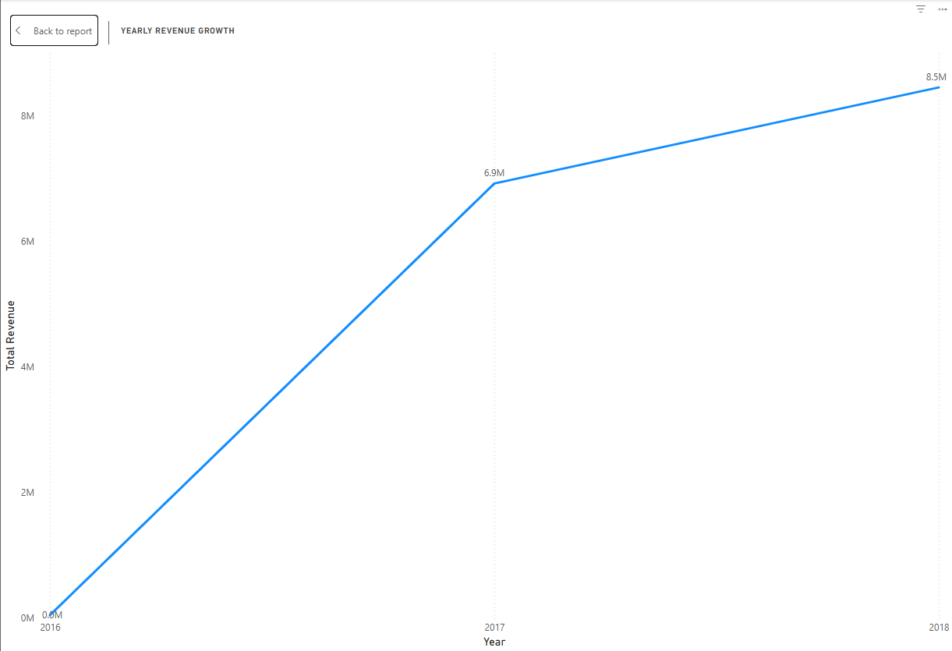
Revenue growth at the yearly level underscores the platform’s rapid expansion. From modest beginnings in 2016, annual revenue surged to ~6.9M in 2017, and further to ~8.5M in 2018, reflecting an approximate 23% year-over-year growth. This trend aligns with quarterly results, showing structural improvements in order volume and customer acquisition. Growth is particularly driven by high-performing categories such as beauty, health, and gifts, alongside geographically concentrated states like SP and RJ. Credit card dominance continues to underpin overall revenue, while boleto supports specific customer demographics. Sustaining momentum will require targeted category expansion, improved logistics for delayed categories, and deeper penetration into mid-tier states, balancing volume growth with fulfillment excellence.
Q6. Question Statement: Compare delayed orders with on-time orders dynamically by month.
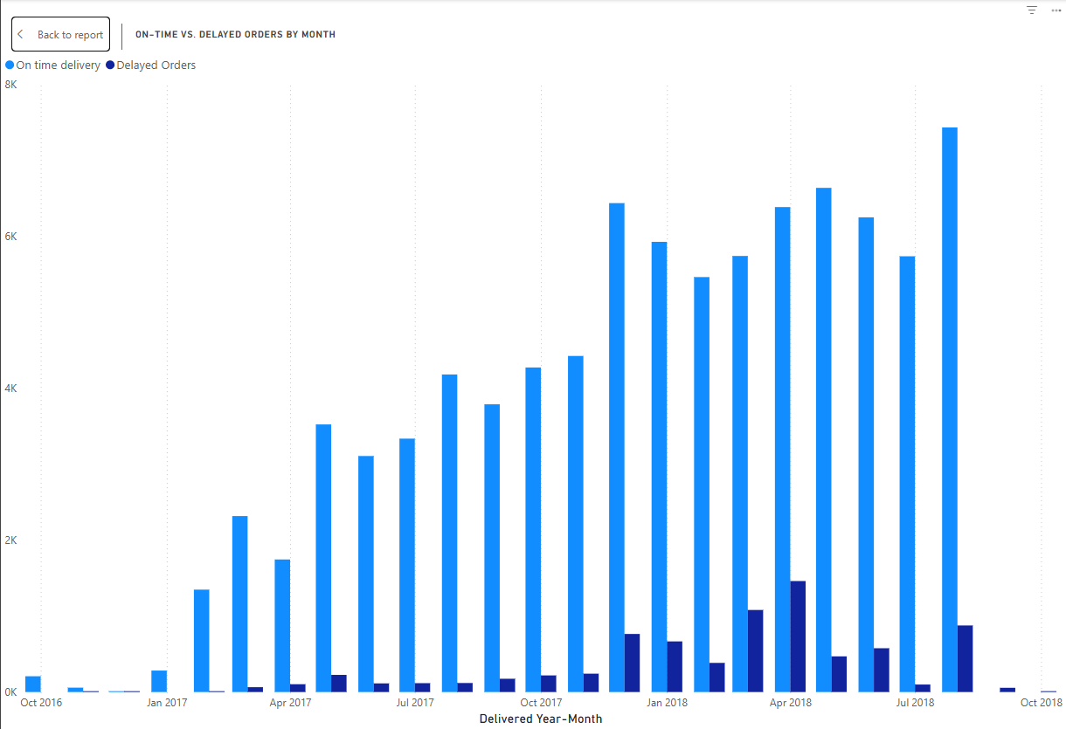
Performance per month indicates that activities of on-time deliveries are growing significantly, starting at early 2017 and reaching about 7-8k orders per month in mid-late 2018. Delayed orders are comparatively smaller in volume, and they also increase in number with the total demand at visible spikes in the high-demand months. This implies pressure in peak seasons even though overall performance was good. The relative increase in the number of delays poses a possible threat to customer satisfaction and loyalty. To handle these problems, it is necessary to plan proactively to purchase more slots with carriers, make the warehouse cut-offs as tight as possible, and reduce SLA buffers during peak periods in a year. Moreover, dissatisfaction can be avoided by a clear communication with customers on delays. In the long run, the evaluation of seller and regional delay patterns will provide opportunities to intervene respectively, minimize complaints and increase Net Promoter Scores.
Q7. Question Statement: Identify and represent the top 10 highest-rated and bottom 10 lowest-rated products.
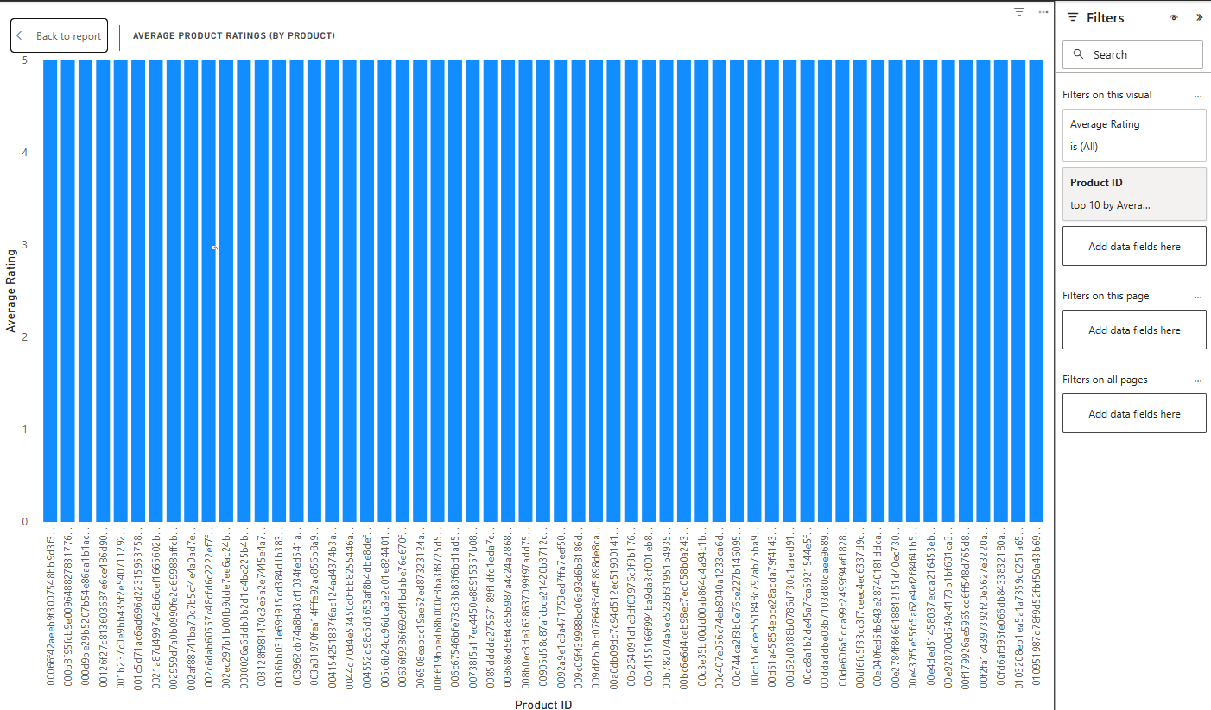
The overall product ratings show a closely concentrated factor of 4.7 to 5.0 indicating a level of unanimously positive customer satisfaction with the catalog. Even though differences are not clearly visible, they are important: items nearer to 4.7 could relate to some slight problems in the form of product description, the packaging, or the reliability of the delivery, whereas those near to 5.0 mean an outstanding customer experience. Absence of extreme outliers implies a wide product-market alignment and quality service. In order to provide more insightful data, the results should be divided into Top 10 highest rated, and Bottom 10 lowest rated products so that the results are not distorted by the lack of reviews. The scores would be weighted to equalize the volume of review with the rating; this would identify those products which would provide genuinely satisfactory results in the long run.
Q8. Question Statement: Determine the number of delayed orders in each product category.
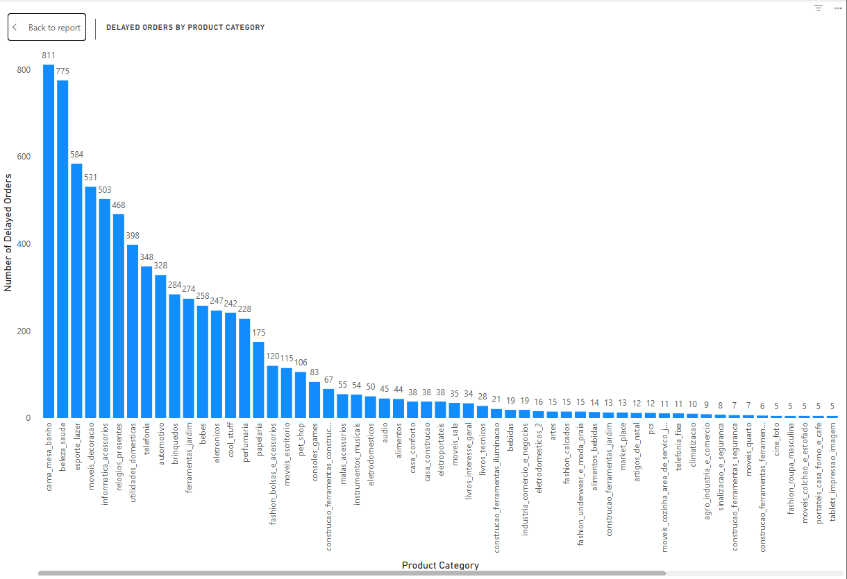
Delayed order analysis shows highest impact in cama_mesa_banho (811 delays) and beleza_saude (775 delays), categories that also drive sales, pointing to fulfillment challenges where demand is strongest. Other significant contributors include esporte_lazer (584), moveis_decoracao (531), informatica_acessorios (503), and relogios_presentes (468). Mid-tier categories like telefonia, automotivo, and brinquedos record delays between 398–284, while lower ranges include ferramentas, bebes, eletronicos, cool_stuff, and perfumaria at 228–274 each. This alignment between top sales and high delays highlights operational strain in fast-moving categories. To improve, inventory planning, cut-off alignment, and logistics reinforcements must focus on top categories, ensuring customer expectations are consistently met and satisfaction levels protected.

